**TEXT ENCRYPTOR/DECRYPTOR**

A Internship Project Report

Submitted in partial fulfillment of the requirements for the award of the degree of

#### MASTER OF SCIENCE (Computer Science)

**Submitted by**

#### MANIARASI M [Reg.No:20224012506109]

Under the Guidance of

## Dr. V. BALAMURUGAN B.E., M.E., Ph.D.,

**Professor**



# Department of Computer Science and Engineering Manonmaniam Sundaranar University

**Tirunelveli-627012 November-2023**

**DEPARTMENT OF COMPUTER SCIENCE AND ENGINEERING MANONMANIAM SUNDARANAR UNIVERSITY**

# TIRUNELVELI-12



**BONAFIDE CERTIFICATE**

This is to certify that the Internship Project entitled **“TEXT ENCRYPTOR / DECRYPTOR”** submitted in partial fulfillment of the degree in **MASTER OF SCIENCE** (Computer Science) to the Department of Computer Science & Engineering, Manonmaniam Sundaranar University, done by **MANIARASI M** Register No. **20224012506109** is an authentic work carried out during the academic year 2023-24.

**GUIDE HEAD OF THE DEPARTMENT**

Submitted for the Viva-Voce Examination on:

## INTERNAL EXAMINER EXTERNAL EXAMINER

**ACKNOWLEDGEMENT**

I thank Lord Almighty, who blessed me with wonderful faculties, friends, and family members whose love and encouragement have given new significance to my accomplishment. I express my sincere thanks with love to my parents, who are ardent cheer leader and support throughout the project. I whole-heartly thank **Dr.A.Suruliandi M.E.,Ph.D.,** Head of the Department of Computer Science and Engineering, Manonmaniam Sundaranar University for providing constructive criticism and suggestions for the successful completion of this project. I thank **Dr.V.Subha B.E.,M.E.,Ph.D.,** Project coordinator, Department of Computer Science and Engineering, Manonmaniam Sundaranar University,Tirunelveli for the consistent encouragement given for the entire project period. I extend my gratitude to my guide **Dr.V.Balamurugan B.E.,M.Tech.,Ph.D.,** Professor, Department of Computer Science and Engineering, Manonmaniam Sundaranar University for his valuable guidance and motivation throughout my project. I thank all staff- members of department for their kind advice and pleasing co-ordination throughout the course. I also thank my friends who support with real encouragement and suggestions in each and every phase of my project.

# DECLARATION

I hereby declare that the project work entitles “**TEXT ENCRYPTOR \ DECRYPTOR”** submitted to Manomaniam Sundaranar University, Tirunelveli in partial fulfillment of the requirement for the award of the degree of Master of Science (Computer Science) is a record of original project work done during the academic year 2023-2024 under the supervision and guidance of **Dr.V.Balamurugan B.E.,M.Tech.,Ph.D.,** Professor, Department of Computer Science and Engineering, Manonmaniam Sundaranar University, Tirunelveli and same work has not been submitted elsewhere for the award of any degree.

**[MANIARASI M ]**

**TABLE OF CONTENTS**

|  |  |  |
| --- | --- | --- |
| **Chapter No.** | **Topic** | **Page No.** |
|  | **ABSTRACT** | 1 |
| **1** | **INTRODUCTION** | **2** |
| **2** | **SYSTEM ANALYSIS**   * 1. Existing System   2. Proposed System | **7** |
| **3** | **SYSTEM REQURIMENTS**   * 1. Hardware Requirements   2. Software Requirements   3. Software Description | **9** |
| **4** | **SYSTEM DESIGN**  4.1. Data Flow Diagram | **11** |
| **5** | **SYSTEM IMPLEMENTATION**   * 1. Sample Source Code   2. Sample Screenshots | **12** |
| **6** | **CONCLUSION** | **20** |
| **7** | **FUTURE ENCHANCEMENT** | **22** |
| **8** | **BIBILIOGRAPHYS** | **23** |

**ABSTRACT**

Now a days internet becomes an essential one for our daily life. Transferring information through internet may not always give confident about our information due to possibility of intrusion. So, we need to transfer the information in a secured manner. Here we go for the mechanism called encryption for transferring our data with high confidence. The encrypted data will get received at the receiver end and the decryption process will take place there for getting the original plain text. The data transferred after the encryption is said to be the cipher text which cannot be understood by any intruder, we need to decrypt the cipher text for getting the original text.

1. **INTRODUCTION**

The "Text Encryptor / Decryptor" project is a user-friendly application thatallows users to secure their messages through encryption and decrypt them when needed. Built with Python's Tkinter library, the project features a simple graphical interface where users can input plain text messages and encrypt them using a custom key. The application employs basic character substitution techniques to create ciphertext, ensuring a unique encryption each time. Userscan also decrypt encrypted messages back to their original form. The project serves as an educational tool, offering insights into fundamental encryption principles. While not suitable for highly sensitive data, it provides a hands-on experience for beginners interested in learning about encryption and its basic mechanisms. The application includes a reset functionality, enhancing user experience by allowing easy clearing of input fields and output labels. Enjoy exploring and experimenting with this interactive text encryption and decryption tool.

1. **SYSTEM ANALYSIS**

A Text Encryptor / Decryptor project involves creating software with auser interface for encrypting and decrypting text. It includes input fields for text, encryption and decryption buttons, and error handling. The system supports various encryption algorithms, manages keys, validates input, and ensures secure data storage. Security, testing, and user documentation are essential. Usability, performance, platform compatibility, deployment, and ongoing maintenance are key considerations for a successful project that safeguards data through encryption and decryption.

#### Existing System

The provided Python code uses the tkinter library to create a GUI application for message encryption and decryption. It uses a character substitution method with a randomly generated key. Users can enter a message, click "Encrypt" to encrypt it, or "Decrypt" to decrypt it, and there's a reset button to clear input fields.

#### Proposed System

The provided Python code utilizes the Tkinter library to create a graphical interface for a basic encryption and decryption tool. Users can input messages, encrypt them using a custom substitution cipher, decrypt encrypted messages, and reset the input fields.

#### Modules Description

**random:** This module is used for generating a random key for encryption. It is used in the random. shuffle(key) line to shuffle the characters in the key list. **string:** This module is used to access string constants like punctuation, digits, and ASCII letters. It is used to define the chars variable, which contains these character sets.

**tkinter:** This module is used for creating the graphical user interface (GUI). It provides functions and classes for building and managing the GUI elements, such as windows, labels, buttons, and input fields.

1. **SYSTEM REQUIREMENTS**

#### Hardware Requirement:

Processor : Intel(R) Core(TM) i3-1115G4 @ 3.00GHz 2.90 GHz RAM : 8.00 GB

#### Software Requirement:

Operating System : Windows 11

Front End : Python(Visual Studio Code)

#### Software Description:

**Python:**

Python is a computer programming language often used to build websites and software, automate tasks, and conduct data analysis. Python is a general-purpose language, meaning it can be used to create a variety of different programs and isn’t specialized for any specific problems It was created by Guido van Rossum, and released in 1991. It was designed with an emphasis on code readability, and its syntax allows programmers to express their concepts in fewer lines of code.

Python is a programming language that lets you work quickly and integrate systems more efficiently.

#### It is used for:

* + - web development (server-side),
    - software development,
    - mathematics,
    - system scripting

#### Uses:

* + - Python can be used on a server to create web applications.
    - Python can be used alongside software to create workflows.
    - Python can connect to database systems. It can also read and modify files.
    - Python can be used to handle big data and perform complex mathematics.
    - Python can be used for rapid prototyping, or for production-ready software development.

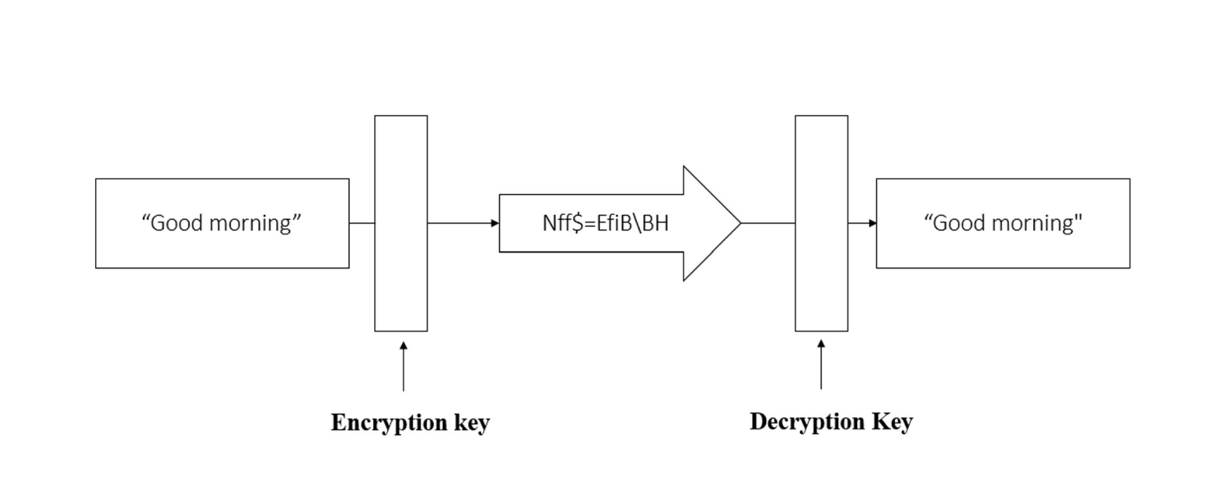

### SYSTEM DESIGN

**4.1 Data Flow Design:**

### SYSTEM IMPLEMENTATION

* 1. **SAMPLE SOURCE CODE:**

import random import string import tkinter as tk

#### # Function to encrypt the message

def encrypt_message():

plain_text = encrypt_input.get() cipher_text = ""

for letter in plain_text:

index = chars.index(letter) cipher_text += key[index]

encrypt_output_label.config(text=f"Original Message:

{plain_text}\nEncrypted Message: {cipher_text}")

#### # Function to decrypt the message

def decrypt_message():

cipher_text = decrypt_input.get() plain_text = ""

for letter in cipher_text:

index = key.index(letter)

plain_text += chars[index]

decrypt_output_label.config(text=f"Encrypted Message:

{cipher_text}\nDecrypted Message: {plain_text}")

#### # Function to reset the input fields and output labels

def reset(): encrypt_input.delete(0, 'end') decrypt_input.delete(0, 'end')

encrypt_output_label.config(text="") decrypt_output_label.config(text="")

#### # Create the window

window = tk.Tk()

window.title("Simple Encryption/Decryption") window.geometry("940x570") window.config(bg="#CFD8DC") window.resizable(0, 0)

#### # Define the character sets and create a key

chars = " " + string.punctuation + string.digits + string.ascii_letters chars = list(chars)

key = chars.copy()

random.shuffle(key)

#### # Set the font size

font_size = 12

#### # Create and configure input and output elements for encryption

encrypt_label = tk.Label(window, text="Encrypt a message:", bg="#CFD8DC", font=("Arial", font_size))

encrypt_label.pack()

encrypt_input = tk.Entry(window, font=("Arial", font_size)) encrypt_input.pack()

encrypt_button = tk.Button(window, text="Encrypt", command=encrypt_message, bg="#CFD8DC", font=("Arial", font_size))

encrypt_button.pack()

encrypt_output_label = tk.Label(window, text="", bg="#CFD8DC", font=("Arial", font_size))

encrypt_output_label.pack()

#### # Create and configure input and output elements for decryption

decrypt_label = tk.Label(window, text="Decrypt a message:", bg="#CFD8DC", font=("Arial", font_size))

decrypt_label.pack()

decrypt_input = tk.Entry(window, font=("Arial", font_size)) decrypt_input.pack()

decrypt_button = tk.Button(window, text="Decrypt", command=decrypt_message, bg="#CFD8DC", font=("Arial", font_size))

decrypt_button.pack()

decrypt_output_label = tk.Label(window, text="", bg="#CFD8DC", font=("Arial", font_size))

decrypt_output_label.pack()

#### # Create and configure the reset button

reset_button = tk.Button(window, text="Reset", command=reset, bg="#CFD8DC", font=("Arial", font_size))

reset_button.pack() window.mainloop()

### 5.1 SAMPLE SCREENSHORTS:

HOME PAGE

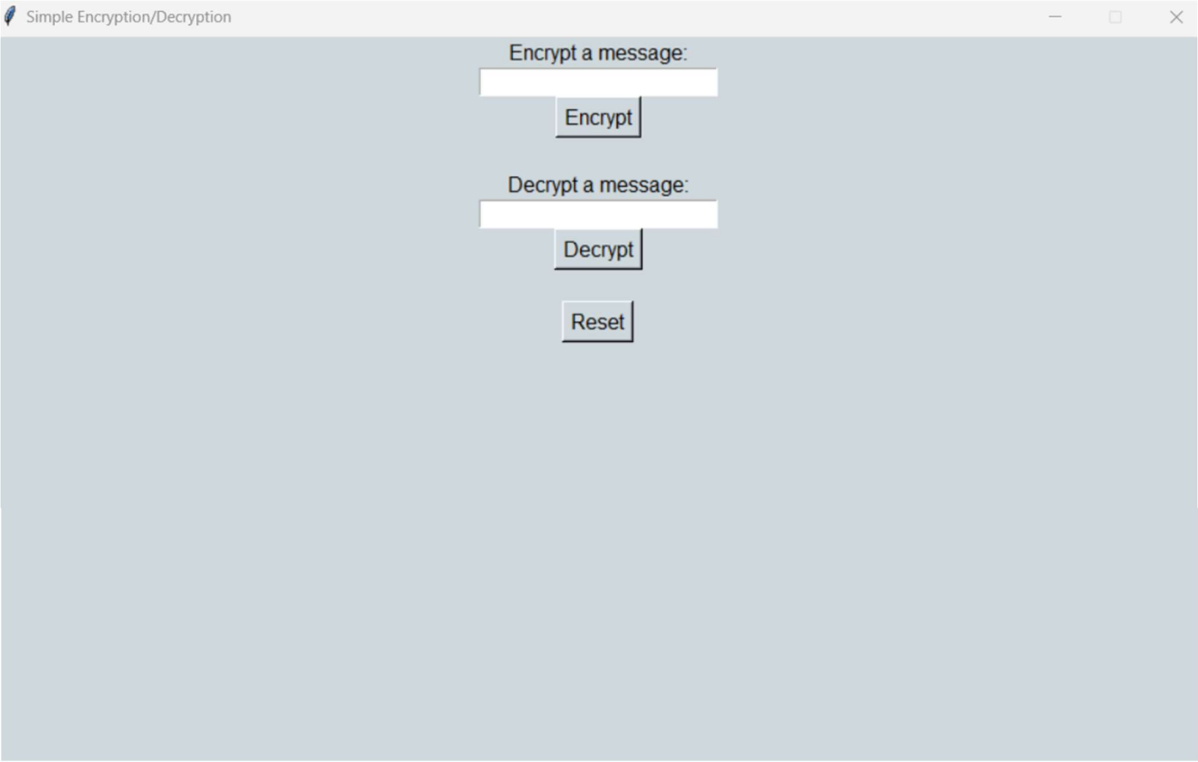

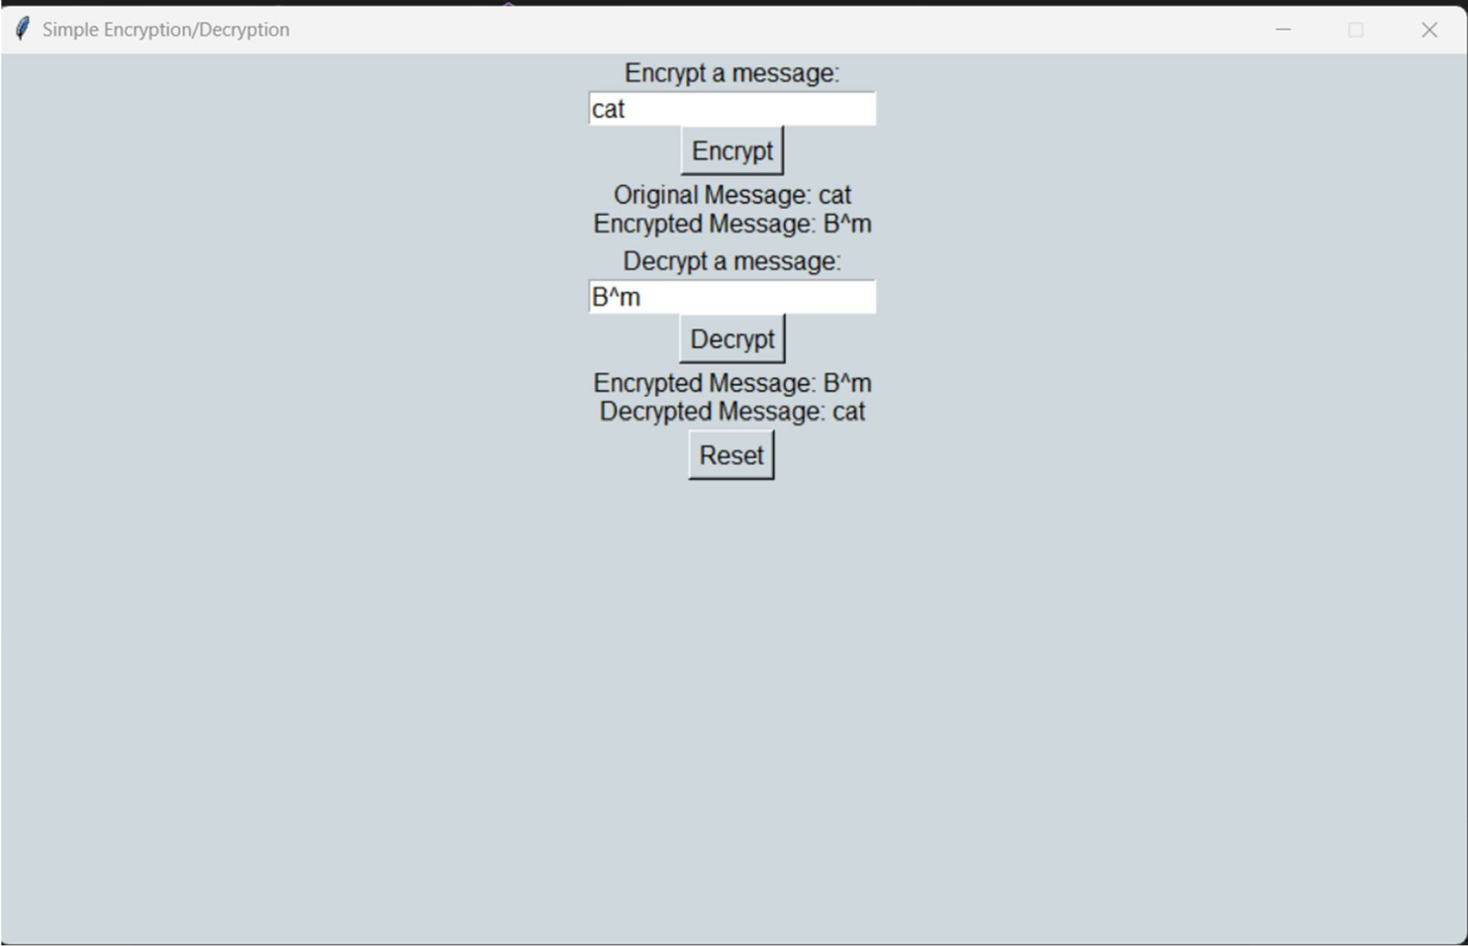

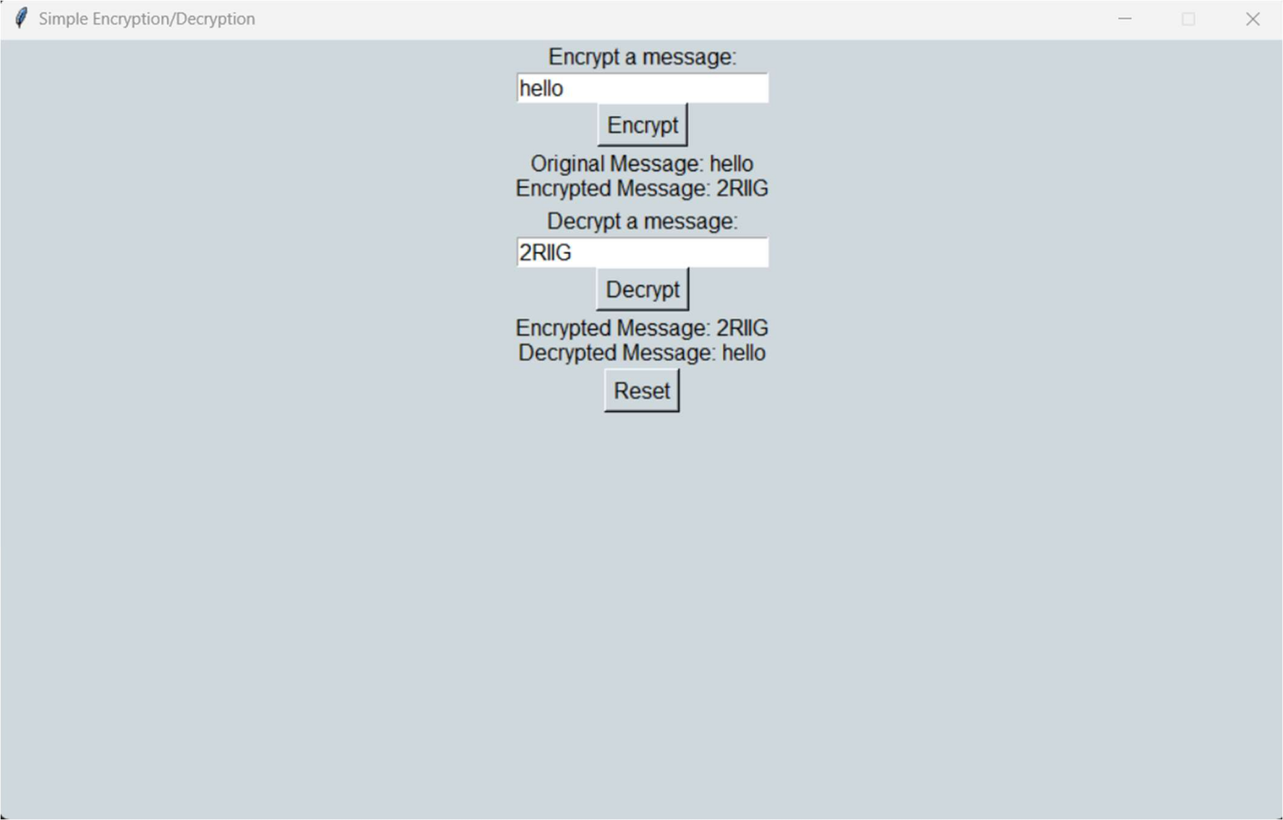

### CONCLUSION

This code creates a Tkinter-based GUI application for simple text encryption and decryption using a substitution cipher. It defines functions for encrypting, decrypting, and resetting the input fields and output labels. The GUI includes input fields, buttons, and labels for both encryption and decryption. Users can enter text to encrypt, decrypt, and reset the input fields. The key for the substitution cipher is generated randomly. Overall, it provides a basic interface for experimenting with text encryption and decryption using a simple substitution cipher.

### FUTURE ENHANCEMENT

Enhance the simple encryption tool by implementing stronger encryption algorithms, user authentication, and file encryption. Improve the GUI, handle errors gracefully, and implement key management and secure key storage. Allow users to save/load keys and set passwords for encryption. Consider internationalization and security auditing.